Interpretation of a Political Cartoon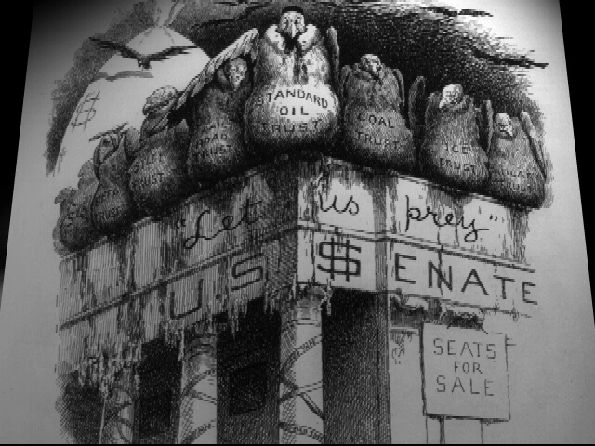
"Let Us Prey" by E.W. Kemble
Group exploration exercise:
- Individually, circle three elements (image, words, feature, etc.) of the cartoon that catch your interest or you have questions about
- One member of your group goes first and selects one of the elements they circled and shares that element
- Moving counterclockwise from that member, each person in the group offers their opinion on the meaning or purpose of that element
- The member then offers their own reasons and summarizes the meaning and purpose of that element
- Repeat the process until everyone has a chance to share one element of the cartoon

Group Writing Exercise - Analysis of a Political Cartoon
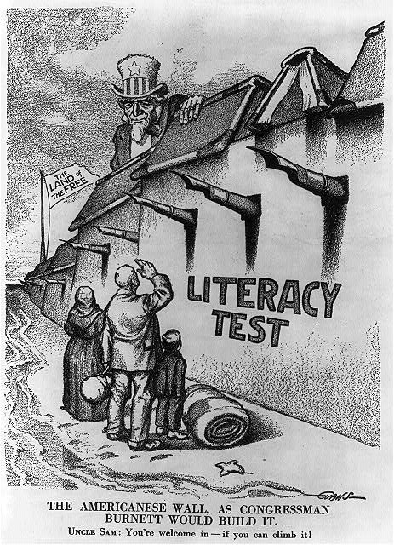
Group writing analysis exercise:
- Individually, craft a sentence that explains the message of this cartoon
- Together, share your sentences and discuss if there is any disagreement until you emerge with a consensus on the message of this cartoon
- Select one group member to write a topic sentence that summarizes your thinking on the message of this cartoon
- Rotate to the next group member, who will write a sentence that supports the first sentence with evidence from the cartoon. Repeat until you have three sentences of evidence to support the topic sentence
- The next group member then writes a concluding sentence that summarizes the message and the evidence from the previous sentences

